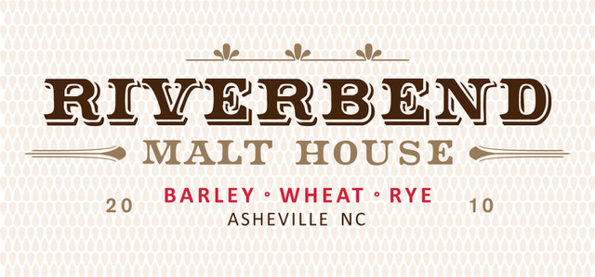

Riverbend Malt House, a leader in the craft malting industry and Asheville’s only craft malt house, is excited to announce an opening for an Assistant Maltster. The individual that fills this position will be a member of the production staff and work with other team members to produce, package and ship high quality malt.

Malted grains are the backbone of the craft fermented beverages that have become a staple in the brewing and distilling markets. Quality malted barley, wheat, rye, oats and corn make craft beers and distilled spirits more exciting by imparting a unique and sought after flavor in the finished product. Riverbend enjoys supplying many local and regional fermenters with the artisanal ingredients they need to make the products we enjoy.

Riverbend is an equal opportunity employer dedicated to providing a harassment-free experience for everyone, regardless of gender, sexual orientation, disability, physical appearance, body size, race, or religion. We do not tolerate harassment of employees, customers, or vendors in any form.

The Assistant Maltster will report directly to the VP of Engineering and Production.

Duties and Responsibilities:

- Perform day to day production needs around the malt house:
  - Loading and unloading malting vessels to start or complete batches
  - Clean and sanitize malting equipment and facility between batches
  - Rake floor malted batches periodically throughout the week
  - Operate seed cleaning equipment to process finished product
  - Operate packaging equipment
  - Operate grain milling equipment
  - Oversee small malt batches running through a custom grain smoker
  - Record important data on batch logs and lab documents
  - Prepare orders and make pallets ready for shipment
  - Other malt house activities that may be required

Position Requirements:

- 40 hours per week with four (10) hours shifts. Hours are 8am to 6pm and work week will be Wednesday to Saturday. One weekend day per week will be required.
- Must be at least 21 years of age.
- Must have a valid driver's license.
- Strong observational skills and attention to detail.
- Ability and desire to learn quickly on the job.
- Must be prepared to spend much of the day standing, walking, climbing ladders, crouching and entering confined spaces utilizing proper safety protocol.
- Must be able to lift 50 pound bags of grain on a repeated basis.
- Ability to work in environments that are hot, dusty and loud (with proper PPE).
- Team player with a positive attitude.
- A high mechanical aptitude is preferred.
- COVID-19 vaccination is required.

Compensation and benefits:

- Starting pay: $15.80/hour (Just Economics certified Living Wage)
- Health care insurance commencing day 1; 100% of employee premiums paid by company.
- Paid holidays, vacation and paid time off.

